- Copyright for test papers and marking guides remains with West Australian Test Papers.
- The papers may only be reproduced within the purchasing school according to the advertised conditions of sale.
- Test papers must be withdrawn after use and stored securely in the school until 15th June.

PHYSICS
UNIT 3
2023

MARKING GUIDE

TIME ALLOWED FOR THIS PAPER

Reading time before commencing work: Ten minutes
Working time for the paper: Three hours

MATERIALS REQUIRED/RECOMMENDED FOR THIS PAPER

To be provided by the supervisor:
- This Question/Answer Booklet; Formula and Constants sheet

To be provided by the candidate:
- Standard items: pens, pencils, eraser or correction fluid, ruler, highlighter.

- Special items: Calculators satisfying the conditions set by the SCSA for this subject.

IMPORTANT NOTE TO CANDIDATES
No other items may be taken into the examination room. It is your responsibility to ensure that you do not have any unauthorised notes or other items of a non-personal nature in the examination room. If you have any unauthorised material with you, hand it to the supervisor before reading any further.

Structure of this paper

Section | Number of questions available | Number of questions to be answered | Suggested working time  (minutes) | Marks available | Percentage of exam
Section One:  Short answer | 11 | 11 | 50 | 54 | 30
Section Two:  Extended answer | 7 | 7 | 90 | 90 | 50
Section Three:  Comprehension  and data analysis | 2 | 2 | 40 | 36 | 20
 |  |  | Total | 180 | 100

Instructions to candidates

- The rules for the conduct of Western Australian external examinations are detailed in the Year 12 Information Handbook 2023. Sitting this examination implies that you agree to abide by these rules.

- Write your answers in this Question/Answer Booklet.

- When calculating numerical answers, show your working or reasoning clearly. Give final answers to three (3) significant figures and include appropriate units where applicable.

When estimating numerical answers, show your working or reasoning clearly. Give final answers to a maximum of two (2) significant figures and include appropriate units where applicable.

- You must be careful to confine your responses to the specific questions asked and follow any instructions that are specific to a particular question.

- Spare pages are included at the end of this booklet. They can be used for planning your responses and/or as additional space if required to continue an answer.
  - Planning: If you use the spare pages for planning, indicate this clearly.
  - Continuing an answer: If you need to use the space to continue an answer, indicate in the original answer space where the answer is continued, i.e. give the page number. Refer to the question(s) where you are continuing your work.

Section One: Short Response 30% (54 Marks)

Suggested working time for this section is 50 minutes.

Question 1 (4 marks)

Element | Description | Marks
uses Faraday’s law | $$ε=-N\frac{∆ϕ}{∆t}$$ | 1
calculates the change in flux | $$∆ϕ=ϕ_{f}-ϕ_{i}$$  $$∆ϕ=BA-BA_{⊥}$$  $$∆ϕ=1.26×\left(0.750×0.750\right)×(1-\cos{50°})$$  $$∆ϕ=0.253 Wb$$ | 1
substitute correct values into Faraday’s law | $$ε=-N\frac{∆ϕ}{∆t}=-1×\frac{0.253}{0.430}$$ | 1
calculates magnitude of the induced emf | $$ε=0.589 V$$ | 1
 | Total | 4

Question 2 (6 marks)

Element | Description | Marks
sums torque about point B and equates net torque to zero | $$Στ_{B}=0$$ | 1
writes clockwise and anticlockwise torques or Cat A, Cat B, and plank about point B | Introduces variable $d$ as distance travelled by Cat A and Cat B from points A and B respectively.  $$Στ_{B}=W_{B}×d-W_{A}×(d+0.500)-W_{p}×0.250=0$$  $$Στ_{B}=m_{B}g×d-m_{A}g×d-0.250m_{p}g=0$$ | 1 – 2
substitutes correct values into torque equation | $$Στ_{B}=\left(4.00×9.8×d\right)-\left(1.50×9.8×(d+0.500)\right)-\left(1.60×9.8×0.250\right)=0$$ | 1
simplifies and calculates distance $d$ | $$39.2d-14.7d-7.35-3.92=0$$  $$24.5d=11.27$$  $$d=0.460$$ | 1
calculates maximum distance between Cat A and Cat B | Max distance $=2×0.460+0.500=1.42$  Max distance $=1.42 m$ | 1
 | Total | 6

Question 3 (5 marks)

(a) On the diagram above draw the external electric field, indicating at least 4 field lines.
(2 marks)

Element | Description | Marks
draws electric field direction | Electric field lines are vertically DOWN. | 1
draws electric field shape | Electric field lines are uniformly spread | 1
 | Total | 2

(b) Calculate the strength of the vertical electric field. (3 marks)

Element | Description | Marks
writes an equation balancing the weight force and electrostatic force | $$W=F_{e}$$  $$mg=Eq$$ | 1
substitutes correct values into equation | $$4.50×{10}^{-3}×9.8=E×7.00×{10}^{-6}$$ | 1
calculates the electric field strength | $$E=6.30×{10}^{3} N/C$$ | 1
 | Total | 3

Question 4 (7 marks)

(a) Calculate the voltage delivered to the primary coil of the step-down transformer. (5 marks)

Element | Description | Marks
calculates current in transmission line | $$I=\frac{P}{V}=\frac{330×{10}^{6}}{265×{10}^{3}}=1245 A$$ | 1 – 2
calculates resistance of line | $$R=40.0 km ×0.225 Ω {km}^{-1}=9.00 Ω$$ | 1
calculates voltage loss in transmission line | $$V_{loss}=IR=1245×9.00=11.2×{10}^{3} V$$ | 1
calculates voltage delivered | $$V=265-11.2=254 kV$$ | 1
 | Total | 5

(b) The secondary coil of the transformer has 100 turns of wire. How many turns of wire does the primary coil have? If you could not determine part (a) you may use a primary voltage of 260 kV. (2 marks)

Element | Description | Marks
uses transformer rule correctly with correct values | $$\frac{V_{p}}{V_{s}}=\frac{253.8}{15}=\frac{N_{p}}{N_{s}}=\frac{N_{p}}{100}$$ | 1
calculates number of turns | $$N_{p}=1690 (1700)$$ | 1
 | Total | 2

Question 5 (4 marks)

Element | Description | Marks
equates friction to the centripetal force required to keep it travelling in a circle | $$F_{f}=F_{c}=\frac{mv^{2}}{r}$$ | 1
calculates velocity from frequency and radius | $$v=\frac{2πr}{T}=2πrf$$  $$v=2π×0.04×17.0=4.27 m/s$$
substitutes correct values into centripetal force expression | $$F_{f}=\frac{44.0×{10}^{-6}{(4.27)}^{2}}{0.04}$$ | 1
calculates centripetal force | $$F_{f}=2.01×{10}^{-2} N$$ | 1
 | Total | 4

Question 6 (6 marks)

(a) Calculate the altitude of the space probe, to the nearest km. (4 marks)

Element | Description | Marks
derives expression for orbital velocity and radius | $$F_{g}=\frac{GMm}{r^{2}}=F_{c}=\frac{mv^{2}}{r}$$  $$v^{2}=\frac{GM}{r}→r=\frac{GM}{v^{2}}$$ | 1
substitutes in correct values | $$r=\frac{6.67×{10}^{-11}×6.39×{10}^{23}}{{\left(3.34×{10}^{3}\right)}^{2}}$$ | 1
calculates radius | $$r=3821 km$$ | 1
calculates altitude | $$altitide=r-r_{M}=3821-3390=431 km$$ | 1
 | Total | 4

(b) Calculate the net acceleration experienced by the space probe. If you could not calculate part (a) you can use an altitude of 400 km. (2 marks)

Element | Description | Marks
uses expression for centripetal acceleration | $$a_{c}=\frac{v^{2}}{r}=\frac{{\left(3.34×{10}^{3}\right)}^{2}}{3821×{10}^{3}}$$ | 1
calculates acceleration | $$a_{c}=2.92 m/s^{2}$$ | 1
 | Total | 2

Question 7 (5 marks)

(a) At the instant shown, current flows anticlockwise from K to H and side KJ moves into the page while side IH moves out of the page. In the dotted boxes above, indicate the polarity (either north – N, or south – S) of the poles on magnets P and Q. (1 mark)

Element | Description | Marks
correctly identifies the polarity of the poles of the magnets | P = South (S)  Q = North (N) | 1
 | Total | 1

(b) Determine the peak voltage and the RMS voltage generated in the loop HIJK, expressing your answers in millivolts (mV). (4 marks)

Element | Description | Marks
uses the formula for emf to find max voltage | $$ε_{max}=2πNBAf$$ | 1
substitutes in correct values and calculates max voltage | $$ε_{max}=2π×1×0.135×\left(0.120×0.07\right)×2.50$$  $$V_{p}=0.0178 V (17.8 mV)$$ | 1
uses RMS voltage formula | $$V_{rms}=\frac{ε_{max}}{\sqrt{2}}=\frac{0.0178}{\sqrt{2}}$$ | 1
calculates RMS voltage | $$V_{rms}=0.0126 V (12.6 mV)$$ | 1
 | Total | 4

Question 8 (5 marks)

(a) Which rope will experience the greatest tensile force? Circle your answer below. (1 mark)

Element | Description | Marks
Gives correct answer | Rope 2 | 1
 | Total | 1

(b) With reference to the principle of equilibrium and other relevant formula, explain your answer to part (a). (4 marks)

Element | Description | Marks
states condition for equilibrium | Sum of horizontal and vertical forces equals zero | 1
recognises horizontal equilibrium | Tension from rope 1 can only be countered by horizontal component of tension of rope 2 | 1
recognises vertical equilibrium | Rope 2 counters the force due to gravity
relates to magnitude of Rope 2 | Thus, tension of rope 2 > Rope 1 | 1 – 2
 | Total | 4

OR

Element | Description | Marks
mentions the sum of forces on drum equal zero | $$ΣF=0$$ | 1
recognises that horizontal component of $T_{1}$ equals $T_{2}$ | $$ΣF_{h}=0=T_{2h}-T_{1}$$  $$T_{2h}=T_{1}$$ | 1
uses trig to relate $T_{1}$ and $T_{2}$ | $$\cos{θ}=\frac{T_{2h}}{T_{2}}=\frac{T_{1}}{T_{2}}$$ | 1
recognises that $\cos{θ}<1$ | $$\frac{T_{1}}{T_{2}}<1 →T_{2}>T_{1}$$ | 1
 | Total | 4

Question 9 (3 marks)

Determine the force per metre due to the Earth’s magnetic field that acts on a high-power transmission line running in a NE direction at the equator. The transmission line is carrying a current of 1.25 × 10³ A and the magnetic field strength at this location is 31.0 µT. You may assume that the magnetic field lines at the equator are parallel to the Earth’s surface.

Element | Description | Marks
uses force equation taking perpendicular component of magnetic field | $$F=B_{⊥}IL=(B\sin{θ)} IL$$ | 1
substitute correct values into force equation | $$F=31.0×{10}^{-6}×\sin{45°}×1.25×{10}^{3}×1.00$$ | 1
calculates force (per meter) | $$F=2.74×{10}^{-2} N$$ | 1
 | Total | 3

Question 10 (4 marks)

(a) In which direction will current flow in the loop in response to this change in flux? Circle your response below. (1 mark)

Element | Description | Marks
Identifies the current direction of the current | CLOCKWISE | 1
 | Total | 1

(b) Explain your answer to part (a) with reference to Lenz’s law. (3 marks)

Element | Description | Marks
Uses Lenz’s law | According to Lenz’s law the induced current will be in such a direction that the associated magnetic flux will oppose the change | 1
Identifies change to the field | Since the field is decreasing into the page, | 1
Identifies and opposition to change required | Thus, any associated current will have a field that works to increase the field into the page | 1
 | Total | 3

Question 11 (5 marks)

A construction worker accidentally fires a nail gun from the top of a 26.0 m high building, releasing the nail horizontally at 34.0 m s^{–1}. Ignoring air resistance, calculate the velocity of the nail just before it hits the ground 26.0 m below.

Element | Description | Element | Description | Marks
uses equation of motion with correct values to find time to fall 26.00 m  calculates time | $$s=ut+\frac{1}{2}at^{2}$$  $$-26.0=0+\frac{1}{2}(-9.8)t^{2}$$  $$t=2.30 s$$ | OR…  Uses initial vertical velocity of zero to calculate final vertical velocity 26.0 m below using vertical displacement… | $$u_{y}=0 m/s$$  $$a=-9.8 m/s^{2}$$  $$s=-26.0 m$$  $$v_{y}^{2}=u_{y}^{2}+2as$$  $$v_{y}^{2}=0+2as$$  $$v_{y}^{2}=0+2×\left(-9.8\right)×(-26.0)$$  $$v_{y}^{2}=509.6$$  $$v_{y}=22.6 m/s$$ | 1 – 2
calculates vertical speed | $$v_{y}=u+at=0-9.8×2.30=22.6 m/s$$ |  |  | 1
uses components to find speed | $$v=\sqrt{v_{x}^{2}+v_{y}^{2}}=\sqrt{{34.0}^{2}+{22.6}^{2}}=40.8 m/s$$ |  |  | 1
determines angle to horizontal | $$\tan{θ}=\frac{v_{y}}{v_{x}}=\frac{22.6}{34}=0.664→θ=33.6°$$ |  |  | 1
 | Total |  |  | 5

Question 12 (15 marks)

(a) With reference to Faraday’s law, explain how the capacitor in the torch is charged.
(4 marks)

Description | Marks
As the magnet slides through the coil, the flux within the coil changes | 1
According to Faraday’s law, when a conductor experiences a change in flux an emf is induced in the conductor proportional to the rate of the change of flux and the number of turns | 1
Due to the resistive nature of the coil, an emf and therefore also a current is induced in the coil | 1
This current is then stored in the capacitor providing electricity for the LED light. | 1
Total | 4

(b) Using the diagram above, indicate the shape of the induced voltage in the coil over the given timeframe on the graph below. There is no need to indicate a vertical scale for the EMF.
(4 marks)

Description | Marks
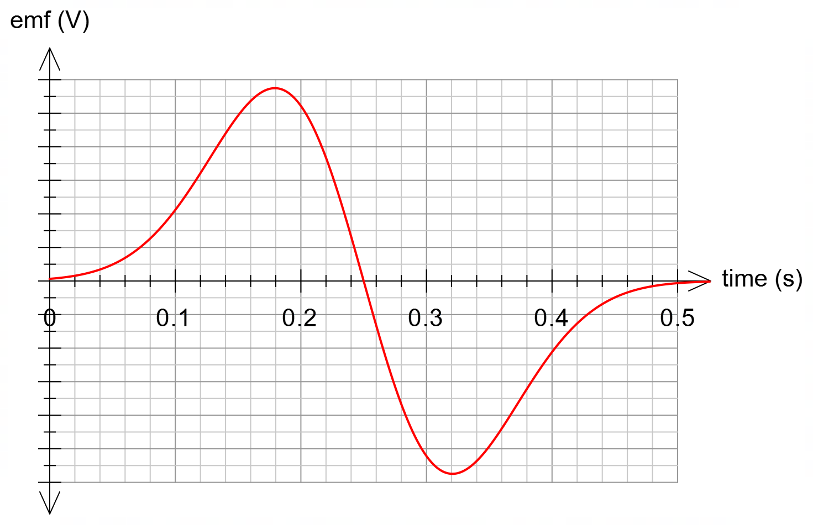
Emf has a max and min either side of 0.25 s | 1
Emf max and min have the same magnitude | 1
Emf starts at zero and ends at zero | 1
Emf is zero at 0.25 s | 1
Total | 4

(c) Using Faraday’s Law for the induced voltage in the coil as well as Ohm’s law, show that the number of turns in the coil can be approximated by the following equation: (3 marks)

$$N=\frac{IR ∆t}{∆B A}$$

Element | Description | Marks
uses both Faraday’s law and Ohm’s law | $$V=IR and V=N\frac{∆∅}{∆t}=\frac{N A ∆B}{∆t}$$ | 1
equates Faraday’s law and Ohm’s law | $$IR=N\frac{∆B A}{∆t}$$ | 1
rearranges for number of turns | $$N=\frac{IR ∆t}{∆B A}$$ | 1
 | Total | 3

(d) When the magnet slides through the coil a peak current of 84.0 mA is generated. Given that the coil has a resistance 3.45 Ω, estimate the number of turns in the coil. Give your answer to an appropriate number of significant figures. (4 marks)

Element | Description | Marks
estimates diameter of coil, max flux density and time from information given in question and from the graph | $$r=0.75 cm (allow 0.75-1.0 cm)$$  $$∆B=1.1 T$$  $$∆t=0.1 s$$  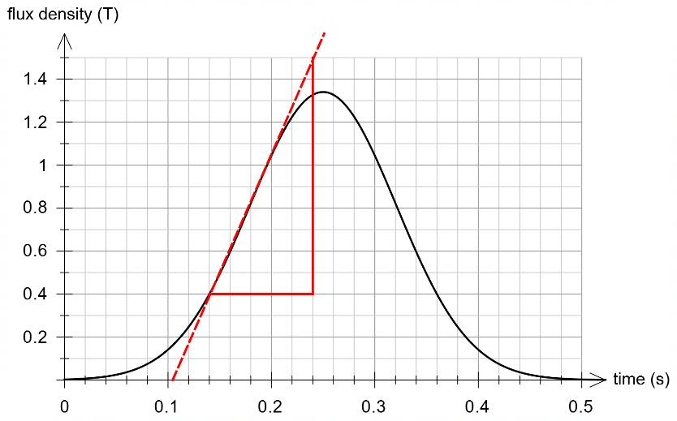 | 1
substitutes values into formula | $$N=\frac{84.0×{10}^{-3}×3.45×0.1}{1.1×π×{0.0075}^{2}}$$ | 1
calculates number of turns | $$N=149.1$$ | 1
gives number of turns to max of 2SF | $$N=150 (allow range:80-160)$$ | 1
 | Total | 4

OR (estimating change in flux and change in time from $t=0$ to $t=0.25$)

Element | Description | Marks
estimates diameter of coil, max flux density and time from information given in question and from the graph | $$r=0.75 cm (allow 0.75-1.0 cm)$$  $$∆B=1.3 T$$  $$∆t=0.25 s$$  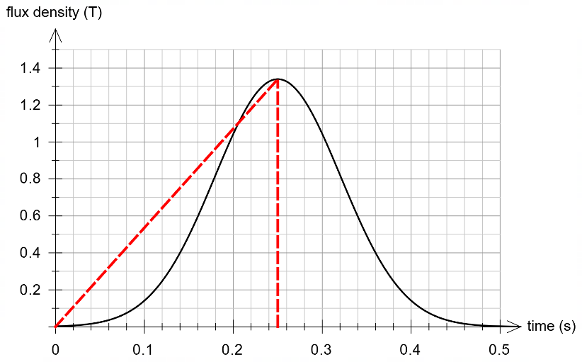 | 1
substitutes values into formula | $$N=\frac{84.0×{10}^{-3}×3.45×0.25}{1.3×π×{0.0075}^{2}}$$ | 1
calculates number of turns | $$N=315.4$$ | 1
gives number of turns to max of 2SF | $$N=320 (allow range:180-330)$$ | 1
 | Total | 4

Question 13 (10 marks)

(a) Identify the direction of the magnetic field at point A due to the current in the transmission wire. Circle the correct answer below. (1 mark)

Element | Description | Marks
correct direction | UP | 1
 | Total | 1

(b) Calculate the strength of the magnetic field 2.00 m from the wire. (3 marks)

Element | Description | Marks
uses correct rule for magnetic field strength | $$B=\frac{μ_{o}}{2π}\frac{I}{r}$$ | 1
substitutes current values into formula | $$B=\frac{4π×{10}^{-7}}{2π}\frac{5.00×{10}^{2}}{2.00}$$ | 1
calculates magnetic field | $$B=5.00×{10}^{-5} T$$ | 1
 | Total | 3

(c) Determine the sum of the clockwise torques acting about the hinge, point P. (3 marks)

Element | Description | Marks
sum torques about hinge | $$Στ_{CW}=W_{wire}×d_{1}+W_{RA}×d_{2}$$ | 1
substitutes correct values into torque equation | $$Στ_{CW}=19.0×1.70+(2.68×9.8)×1.40$$ | 1
calculates correct torque | $$Στ_{CW}=69.1 Nm$$ | 1
 | Total | 3

(d) Using your answer from part (c), determine the tension in the supporting cable. If you could not determine part (c) you may use a net clockwise torque of 70 Nm. (3 marks)

Element | Description | Marks
equates ACW torque to CW torque | $$Στ_{CW}=Στ_{ACW}$$ | 1
uses value from (c) and using correct trig (sine) and correct distance (1.25 m) | $$69.1=T×\sin{52.0°}×1.25$$ | 1
calculates correct tension | $$T=70.1 N (71.1 N)$$ | 1
 | Total | 3

Question 14 (13 marks)

(a) Determine the speed at which the table tennis ball hits the ceiling. (3 marks)

Element | Description | Marks
uses correct equation of motion | $$v^{2}=u^{2}+2as$$ | 1
substitutes correct displacement, acceleration, and initial speed, adopting a sign convention | $$v^{2}={5.00}^{2}+2×(-9.8)×(1.00)$$ | 1
calculates velocity (ignoring negative value) | $$v=2.32 m/s$$ | 1
 | Total | 3

(b) Calculate the time of flight of the table tennis ball, from release to catch. (5 marks)

Element | Description |  | Marks
uses correct equation to determine $t_{1}$ | $$v_{1}=u_{1}+at_{1} →t_{1}=\frac{v_{1}-u_{1}}{a}$$ |  | 1
substitutes correct values to calculate $t_{1}$ | $$t_{1}=\frac{2.32-5.00}{-9.8}=0.273 s$$ |  | 1
uses either method to calculate $t_{2}$, time from ceiling to catch | $$s_{2}=u_{2}t_{2}+\frac{1}{2}at_{2}^{2}$$  $$-1.50=-2.32t_{2}-4.9t_{2}^{2}$$ | $$v_{2}^{2}=u_{2}^{2}+2as$$  $$v_{2}^{2}={\left(-2.32\right)}^{2}+2×(-9.8)×(-1.50)$$  $$v_{2}=-5.90 m/s$$ | 1
solves for $t_{2}$ | solves quadratic.  $$4.9t_{2}^{2}-2.32t_{2}-1.50=0$$  $$t_{2}=0.365 s$$ | $$t_{2}=\frac{v_{2}-u_{2}}{a}$$  $$t_{2}=\frac{-5.90--2.32}{-9.8}$$  $$t_{2}=0.365 s$$ | 1
adds times $t_{1}$ and $t_{2}$ | $$t=0.273+0.365=0.638 s$$ |  | 1
 | Total |  | 5

(c) Draw a velocity–time graph for the table tennis ball from the point of release to the point of catch. Indicate a suitable scale on both axes. You may assume that upwards is a positive velocity. (5 marks)

Element | Description | Marks
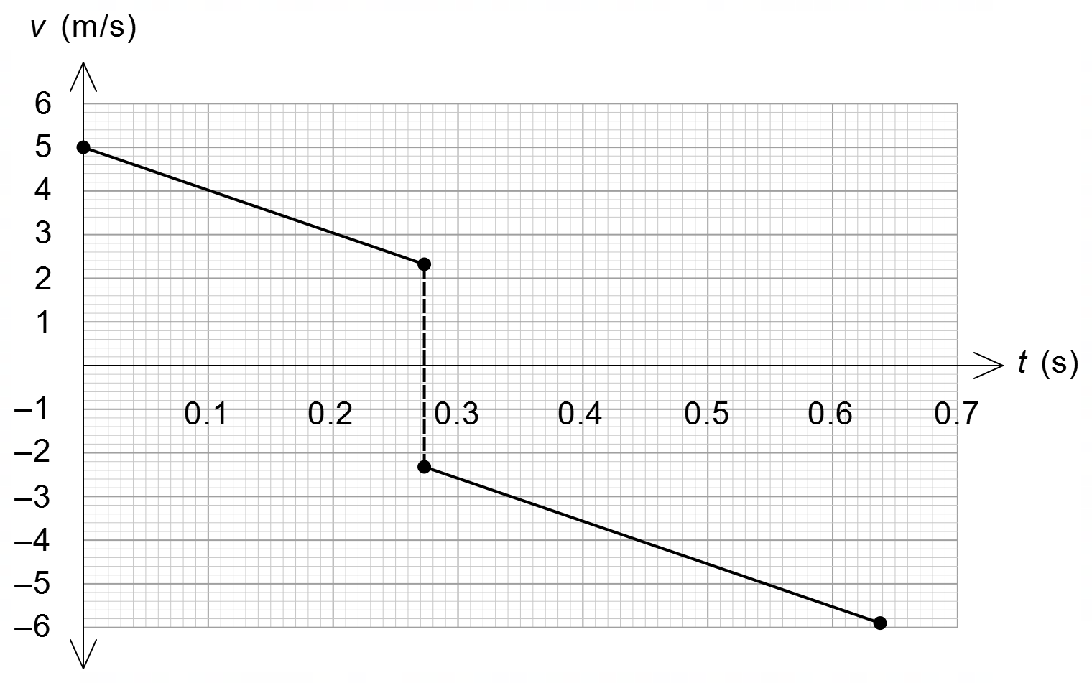
plots initial velocity correctly | $$u=5.00$$ | 1
plots velocities of hitting the ceiling | $$v_{1}=2.32$$  $$u_{2}=-2.32$$ | 1
plots the final velocity correctly | $$v_{2}=-5.90$$ | 1
plots acceleration correctly | constant acceleration ($a=-9.8)$; i.e., slope of lines is constant. | 1
indicates appropriate scale | indicates scale on horizontal and vertical scales | 1
 | Total | 5

Question 15 (14 marks)

(a) In the space below, draw a vector diagram of the forces acting on the ball, indicating the net force and any relevant angles. (3 marks)

Element | Description | Marks
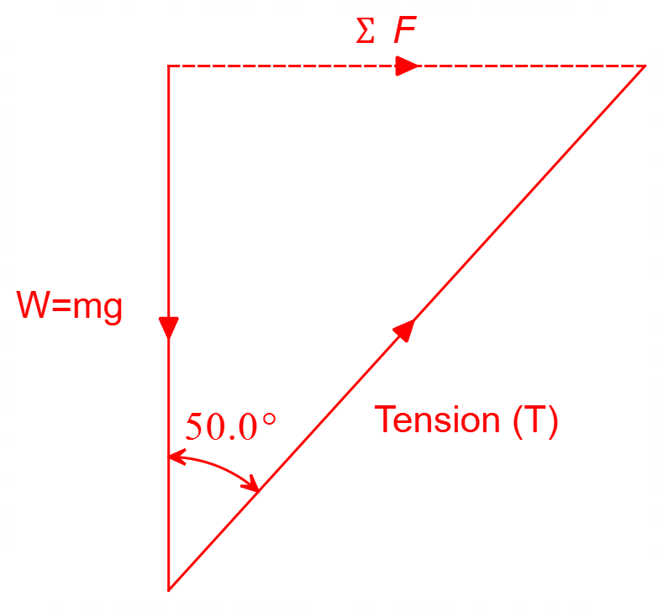
indicates forces | Draws tension force and weight force only | 1
indicates net force | Indicates net force pointing towards centre of revolution | 1
includes angles | Includes angle of 50.0° between tension and weight force | 1
 | Total | 3

(b) Calculate the tension in the wire. (3 marks)

Element | Description | Marks
equates weight force with vertical component of tension | $$T_{y}=W=mg$$  $$T\cos{θ}=mg$$ | 1
substitutes correct values | $$T\cos{50.0°}=1.50×9.8$$ | 1
calculates tension in the wire | $$T=\frac{1.50×9.8}{\cos{50.0°}}=22.9 N$$ | 1
 | Total | 3

(c) Calculate the speed of the ball. If you could not calculate part (b) you may use a tension force of 25 N. (5 marks)

Element | Description | Marks
calculates radius | $$r=1.50×\sin{50.0}=1.15 m$$ | 1
calculates horizontal tension component | $$T_{x}=T\sin{50.0°}=22.9×\sin{50.0°}$$  $$T_{x}=17.5 N (19.2)$$ | 1
equates horizontal component of tension to centripetal force | $$T_{x}=F_{c}=\frac{mv^{2}}{r}$$ | 1
substitutes correct values | $$17.5=\frac{1.50{×v}^{2}}{1.15}$$ | 1
solves for velocity | $$v=3.66 m/s (3.83)$$ | 1
 | Total | 5

(d) The speed of the ball is now doubled. Explain, with relevant physics, why the angle of the wire to the vertical increases as the speed of the ball doubles. (3 marks)

Description | Marks
The horizontal component of the tension force will increase (since the centripetal force $F_{c}∝v^{2}$) | 1
The vertical component of the tension force remains unchanged since it counteracts the weight force. | 1
Since the horizontal component of the tension force increases and the vertical component remains the same, the angle with the vertical will increase. | 1
Total | 3

Question 16 (11 marks)

(a) The coil starts from the position shown and a potential difference of 15.0 V is applied across the terminals of the coil, drawing a current of 5.00 A in the coil.

(i) In which direction will side CD move? Circle your answer. (1 mark)

Element | Description | Marks
Correct Response | OUT OF PAGE | 1
 | Total | 1

(ii) Determine the torque experienced by the coil at the position shown. (3 marks)

Element | Description | Marks
uses torque equation | $$τ=2NBILr$$ | 1
substitutes correct values | $$τ=2×15×0.316×5.00×0.24×0.09$$ | 1
calculates correct torque | $$τ=1.02 Nm$$ | 1
 | Total | 3

(b) It is observed that as the motor spins faster and faster the coil draws less current and the net voltage across the coil reduces according to the equation:

(i) Explain how back emf ($ε_{back}$) is generated in the coil. (3 marks)

Description | Marks
As the motor spins faster the coil acts like a generator and the coil experiences a change of flux | 1
An emf is induced in the coil proportional to rate of change of flux (speed) | 1
According to Lenz’s law the induced emf is in the opposite direction to the applied voltage and thus oppose the supply voltage. | 1
Total | 3

(ii) At maximum speed the coil draws a peak current 1.26 A. Determine the rate at which the coil will spin at maximum speed. (4 marks)

Element | Description | Marks
determines net voltage | $$V_{net}=1.26×3.00=3.78 V$$ | 1
calculates $ε_{back}=V_{supply}-V_{net}$ | $$ε_{back}=15.0-3.78=11.22 V$$ | 1
relates back emf voltage to frequency | $$ε_{back}=2πNBAf$$  $$11.22=2π×15×0.316×0.18×0.24f$$ | 1
solves for frequency | $$f=8.72 Hz$$ | 1
 | Total | 4

Question 17 (14 marks)

A circus performer is rotating an 8.50 × 10² g flaming torch on the end of a 1.20 m string. Once the torch is brought up to speed it rotates freely under the influence of gravity in a vertical circular path of radius 1.20 m. The string can withstand a tensile force of 60.0 N before it snaps.

(a) Identify the position where the tension in the string will be greatest (top – point T, middle – point M or bottom – point B). Circle your answer below. (1 mark)

Element | Description | Marks
correct response | Point B | 1
 | Total | 1

(b) With the use of a suitable calculation, show that the tension in the string never reduces to zero as the torch follows its circular path. (3 marks)

Element | Description | Marks
identifies the top as point of minimum tension and writes force equation for tension | $$ΣF=W+T=F_{c}$$  $$∴T=F_{c}-W$$ | 1
substitutes correct values | $$T=\frac{mv^{2}}{r}-mg$$  $$T=\frac{0.850×{4.12}^{2}}{1.20}-0.850×9.8$$ | 1
solves for tension | $$T=3.69 N$$ | 1
 | Total | 3

(c) Determine whether the string can withstand the forces it experiences as it undergoes the circular motion described. Justify your answer with a relevant calculation. (4 marks)

Element | Description | Marks
identifies the bottom as point of max tension | $$ΣF=T-W=F_{c}$$  $$∴T=F_{c}+W$$ | 1
substitutes correct values | $$T=\frac{mv^{2}}{r}+mg$$  $$T=\frac{0.850×{8.00}^{2}}{1.20}+0.850×9.8$$ | 1
solves for tension | $$T=53.7 N$$ | 1
explains that string will not snap | Since tension < 60.0 N rope will not snap | 1
 | Total | 4

(d) Using an energy consideration, show that the centripetal acceleration of the flaming torch at point M is approximately 34 m s^{–2}. (6 marks)

Element | Description | Marks
uses energy at point M and either point T or point B | $$ΣE_{B}=ΣE_{M}$$ | 1
substitutes values into kinetic and potential energy | $$\frac{1}{2}mv_{B}^{2}=\frac{1}{2}mv_{M}^{2}+mgh_{M}$$  $$\frac{1}{2}×0.85×{8.00}^{2}=\frac{1}{2}×0.85×v_{M}^{2}+0.85×9.8×1.20$$ | 1 – 2
solves for velocity at M | $$v_{M}=6.36 m/s$$ | 1
calculates centripetal acceleration | $$a_{c}=v^{2}/r= {6.36}^{2}/1.20$$ | 1
calculates $a_{c}$ | $$a_{c}=33.7 m/s^{2} (\sim 34 m/s^{2})$$ | 1
 | Total | 6

Question 18 (13 marks)

(a) Using the information given and data from your Formula and Data Booklet, show that the orbital period of Eris is approximately 560 Earth years. (5 marks)

Element | Description | Marks
uses Kepler’s 3rd Law | $$\frac{T^{2}}{r^{3}}=\frac{4π^{2}}{GM}$$ | 1
rearranges for time | $$T^{2}=\frac{4π^{2}r^{3}}{GM}$$  $$T=\sqrt{\frac{4π^{2}r^{3}}{GM}}$$ | 1
substitutes correct values of radius of Eris and mass of Sun | $$T=\sqrt{\frac{4π^{2}{(1.02×{10}^{13})}^{3}}{(6.67×{10}^{-11})(1.99×{10}^{30})}}$$ | 1
calculates time in seconds | $$T=1.78×{10}^{10} seconds$$ | 1
converts time to earth years | $$T=\frac{1.78×{10}^{10}}{365×24×3600}=563 earth years$$ | 1
 | Total | 5

(b) Calculate the orbital speed of the moon Dysnomia about Eris. (3 marks)

Element | Description | Marks
equates gravitational and centripetal force to find expression for orbital velocity | $$F_{c}=\frac{mv^{2}}{r}=F_{g}=\frac{GMm}{r^{2}}$$  $$→v=\sqrt{\frac{GM}{r}}$$ | 1
substitutes correct values | $$v=\sqrt{\frac{(6.67×{10}^{-11})(1.66×{10}^{22})}{3.73×{10}^{7}}}$$ | 1
solves for velocity | $$v=172 m/s$$ | 1
 | Total | 3

(c) The mass of the moon Dysnomia is difficult to calculate, given it is not known whether it is a solid object or not. However, it has been estimated that it could be between 37 and 115 times smaller than the mass of Eris. Using calculations, express the mass of Dysnomia with an associated uncertainty. Give your answers to an appropriate number of significant figures. (5 marks)

Element | Description | Marks
calculates smallest and largest mass of Dysnomia | $$m_{small}=\frac{1.66×{10}^{22}}{115}=1.44×{10}^{20} kg$$  $$m_{large}=\frac{1.66×{10}^{22}}{37}=4.49×{10}^{20} kg$$ | 1
calculates average value | $$m_{avg}=\frac{(1.44+4.49)×{10}^{20}}{2}=2.96×{10}^{20} kg$$ | 1
calculates tolerance | $$∆m=\frac{(4.49-1.44)×{10}^{20}}{2}=1.52×{10}^{20} kg$$ | 1
expresses answer | $$m=2.96×{10}^{20}±1.52×{10}^{20} kg$$ | 1
to max of 2 SF | $$m=3.0×{10}^{20}±1.5×{10}^{20} kg$$ | 1
 | Total | 5

Question 19 (18 marks)

The Hall Effect

(a) By using Equation 1 and relevant formulae from your Formula and Data Booklet, show that the Hall Voltage ($V_{H}$) is given by the equation below. (4 marks)

Element | Description | Marks
equates magnetic and electric force (from Data Booklet) | $$F_{B}=F_{E}$$  $$q_{e}v_{d}B=Eq_{e}$$ | 1
substitutes $v_{d}$ from Equation 1 and $V_{H}/w$ for $E$ | $$q_{e}\left(\frac{I}{n q_{e} A}\right)B=\left(\frac{V_{H}}{w}\right)q_{e}$$ | 1
writes area $A=w×d$ | $$\frac{I B}{n q_{e} (w×d)}=\frac{V_{H}}{w}$$ | 1
rearranges for $V_{H}$ | $$∴V_{H}=\frac{I B w}{n q_{e} w d}=\frac{I B}{n q_{e} d}$$ | 1
 | Total | 4

(b) On the graph on the next page construct a graph of Hall Voltage $V_{H}$ (V) versus current $I$ (A). Indicate an appropriate scale and draw in a line of best fit through the data. (4 marks)

Description | Marks
plots voltage $V_{H}$ on vertical axis and current $I$ on horizontal axis | 1
plots points accurately | 1
indicates an appropriate scale | 1
draws in a line of best fit | 1
Total | 4

(c) Calculate the gradient of the line of best fit. Indicate construction lines and coordinates of the points used. Include units in your answer. (4 marks)

Element | Description | Marks
identifies points from graph using construction lines | (59, 3)  (98, 5) | 1
calculates gradient using rise over run, including scale factor for voltage | $$m=\frac{∆V}{∆I}=\frac{\left(5-3\right)×{10}^{-6}}{98-59}$$ | 1
calculates gradient | $$m=5.13×{10}^{-8} (5.1-5.2×{10}^{-8})$$ | 1
includes units | Units = $V A^{-1}$ | 1
 | Total | 4

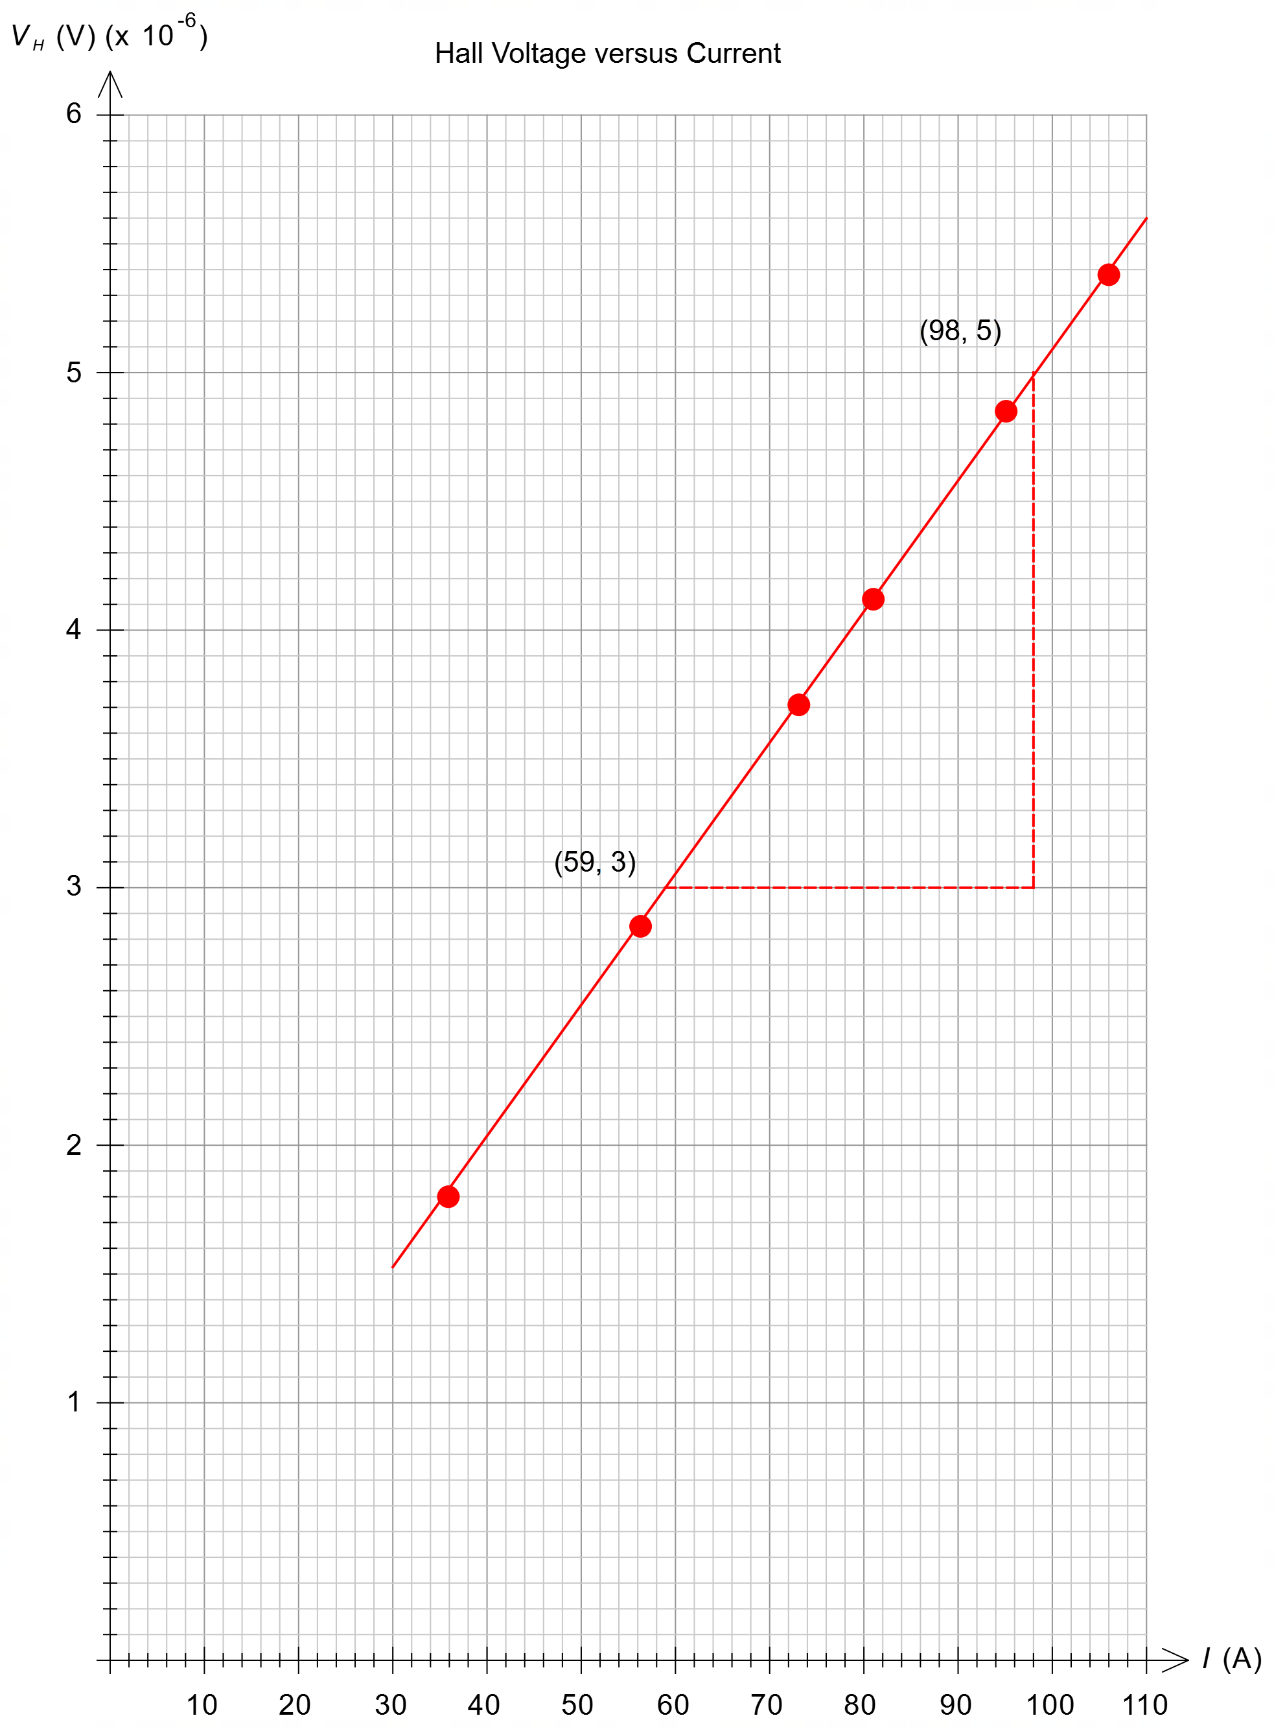

(d) Use your gradient of your line of best fit to determine the charge carrier density $n$ of the copper metal used in this experiment. Give your answer to an appropriate number of significant figures. If you could not calculate the gradient of your line of best fit, you may use a gradient of 5.0 × 10^{–8}. (4 marks)

Element | Description | Marks
identifies gradient from relationship and rearranges for charge carrier density $n$ | $$m=\frac{B}{n q_{e} d}$$  $$→n=\frac{B}{m q_{e} d}$$ | 1
substitutes values | $$n=\frac{2.76}{\left(5.13×{10}^{-8}\right)\left(1.6×{10}^{-19}\right)(4.00×{10}^{-3})}$$ | 1
calculates charge carrier density | $$n=8.41×{10}^{28}$$ | 1
gives answer to max 2 SF | $$n=8.4×{10}^{28} (8.6×{10}^{28})$$ | 1
 | Total | 4

(e) Explain how a device using the Hall Effect could be used to detect a current in a nearby conductor. (2 marks)

Description | Marks
A current in a conductor will have an associated magnetic field. | 1
Since the Hall Effect is sensitive (and detects) magnetic fields via $V_{H}$ it can be used to detect this current if distance from the wire is known. | 1
Total | 2

Question 20 (18 marks)

Gravitational Potential Energy & Escape Velocity

(a) State two reasons why the assumption that the gravitational potential energy of an object anywhere as given by Equation 1, is invalid. (2 marks)

Description | Marks
Reason 1: the acceleration due to gravity varies with distance. | 1
Reason 2: using $U=mgh$ would result in decreasing potential energies with increased distance, rather than increased potential energies. | 1
Total | 2

(b) Diagram 1 shows an object at two positions (1 and 2). By using Equation 4, show that the change in the gravitational potential energy of this object, as it moves from position 1 to position 2, is a positive value. (3 marks)

Element | Description | Marks
uses potential energy formula and subtracts initial from final ($U_{2}-U_{1}$) | $$∆U=\left(-\frac{GMm}{r_{2}}\right)-\left(-\frac{GMm}{r_{1}}\right)=GMm\left(\frac{1}{r_{1}}-\frac{1}{r_{2}}\right)$$ | 1
recognises that $r_{2}>r_{1}$ | Since $r_{1}<r_{2}$ therefore:  $$\frac{1}{r_{1}}>\frac{1}{r_{2}}$$ | 1
comments on $∆U$ | Thus $∆U$ is positive | 1
 | Total | 3

(c) On Diagram 2, draw the gravitational potential energy curve for the object that escapes the gravity of an attracting body. (2 marks)

Description | Marks
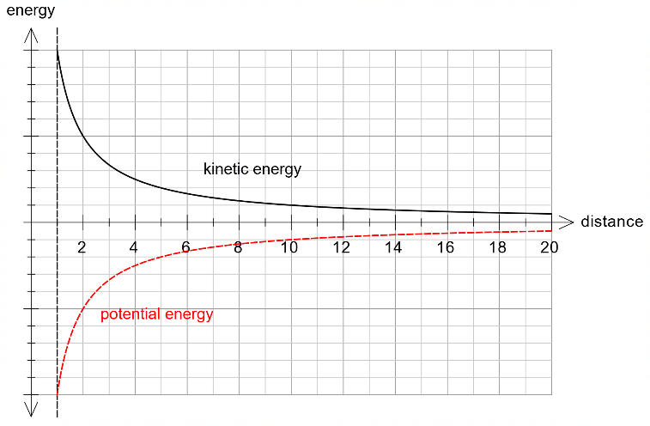
potential energy curve is negative | 1
potential energy curve shape is identical to kinetic energy curve | 1
Total | 2

(d) Calculate the escape velocity of a rocket from the surface of the Earth. (3 marks)

Element | Description | Marks
uses correct formula | $$v_{e}=\sqrt{\frac{2GM}{r}}$$ | 1
substitutes correct values of mass of Earth and radius of Earth | $$v_{e}=\sqrt{\frac{2×6.67×{10}^{-11}×5.97×{10}^{24}}{{6.37×10}^{6}}}$$ | 1
calculates correct velocity | $$v_{e}=11.2 km/s$$ | 1
 | Total | 3

(e) Would the escape velocity from the surface of the Moon be greater or smaller than the escape velocity from the surface of the Earth? Justify your response using relevant information from the text and data from your Formula and Data Booklet. No calculations are necessary. (4 marks)

Element | Description | Marks
refers to mass of earth and moon refers to radius of earth and moon | Mass of Earth is about 81 times larger than mass of the Moon  Radius of the Earth is about 3.7 times larger than the radius of the Moon | 1
uses formula for comparison | $$v_{e}∝\sqrt{\frac{M}{r}}$$ | 1
makes comparison | Since the mass of the moon decreases much greater than the radius of the moon does, the escape velocity on the moon is much less than that on the Earth | 1
correct response | Thus, smaller | 1
 | Total | 4

(f) The Voyager 1 space probe is in space beyond the solar system at a distance from the Earth of 158 AU (1 AU = 1.50 × 10¹¹ m). At this distance the 722 kg space probe can only gain about 12 kJ more potential energy due to the Earth’s gravitational field. Verify this energy estimate with an appropriate calculation. (4 marks)

Element | Description | Marks
converts AU to m | $$r=158×1.50×{10}^{11}=2.37×{10}^{13} m$$ | 1
makes final potential energy zero | $$∆U=0-\left(-\frac{GMm}{r}\right)=\frac{GMm}{r}$$ | 1
substitutes correct values | $$∆U=\frac{GMm}{r}=\frac{6.67×{10}^{-11}×5.97×{10}^{24}×722}{2.37×{10}^{13}}$$
calculates correct energy | $$∆U=12.1×{10}^{3} J$$ | 1
 | Total | 4

End of Questions

